IN 22
ELECTRONIC PATIENT CARE BED, 2 MOTORS
- Electrical operated backrest and legrest adjustment
- Fowler and Vascular positions
- Hand remote control
- Detachable PP head and foot boards
- Auto-contour
- Easily cleanable, lockable and fold-away PP side rails
- Auto-regression system for backrest
- Easy removable ABS mattress platform
- Angle indicator for backrest
- Electrostatic powder coated metal frame
- Footrest adjustment by ratchet
- Height adjustable IV pole
- 125 mm diagonal lockable castors
- Protective plastic corner bumpers
- Dual side manual CPR levers at backrest (optional)
- Trendelenburg position (optional)
- IPX6 standard electronic system
Other Infinitum Electronic Bed
 | TECHNICAL DETAILS
 | Overall Length | : 216 cm
 | Overall Width | : 102 cm
 | Height | : 46 cm
 | Backrest Angle | : 0°-70°
 | Legrest Angle | : 0°-35°
 | Castor Diameter | : 12,5 cm
 | Under Bed Clearance | : 12,5 cm
 | Safe Working Load | : 250 kg
—
 | ELECTRICAL DATA
 | Power In | : 1.5A max. At 230V AC 50-60 Hz
 | Electrical Shock Protection | : Class I, Type B
 | Liquid Ingress Protection | : IPX6

ACCESSORIES
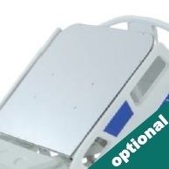
X-Ray Translucent Backrest with Cassette Holder
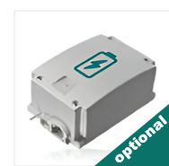
Rechargeable Battery Backup
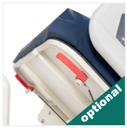
Dual Sided Manual CPR at Backrest
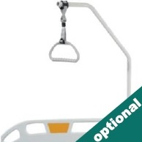
Lifting Pole

Trendelenburg by Gas Spring
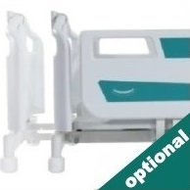
Bed Extension
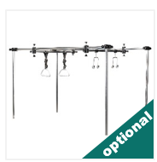
Orthopedic Traction System
COLOR CHART
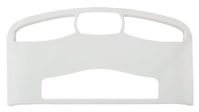
P01
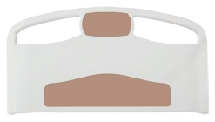
P02
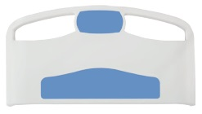
P03
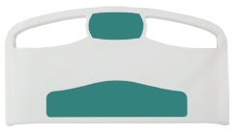
P04
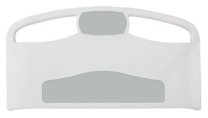
P05
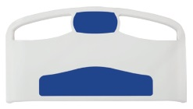
P06
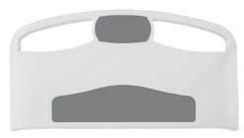
P07
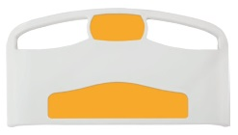
P08

